Symbol☺

**BOKAMOSO SHOGOE**

**GRADE 10C**

**18 APRIL**

**CLASS ACTIVITY** 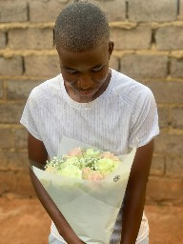

Text box

uThando lweslima uzoli khumbula mhla aboclever baku jikela

IsiZulu Qoutes